CRESWICK PRIMARY SCHOOL
PREP BOOKLIST 2023
QUANTITY | SPECIFIC TYPE | PRODUCT
4 | Writer Premium 64-page Story Book - 100gsm Paper, Plain/ 24mm Ruled, Red Margin | 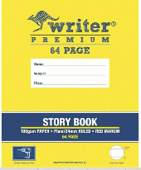
6 | Scrap Books White Bond – 64 Page | 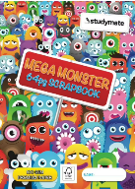
1 | Studymate 165x240 100gsm Mini Monster Scrapbook 64 Page | 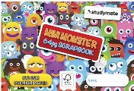
1 | Black – Italplast Green-R Magazine Stand Black | 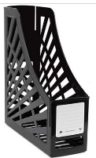
1 | Document Wallet Blue

QUANTITY | STATIONERY ITEMS
1 | Headphones – child sturdy ones
4 | Whiteboard Markers – black, bullet tip (Staedtler Lumocolour brand please)
1 | Studymate Soft Grip Scissors
8 | Glue Sticks (Bostik brand please)
1 | Eraser
1 | Coloured Pencils -12pkt (Faber-Castell brand please)
1 | Zoom Twistable Crayons (12 pkt)
1 | Coloured Textas 12pkt (Faber-Castell brand, not connector textas please)
10 | Junior Triangular Grey-lead Pencils 2B (Faber-Castell brand please)
4 | A4 Recycled White Copy Paper 80gsm
2 | Boxes of tissues

PREP BOOKLIST 2023

Dear Parents and Carers,
Please find attached your child’s 2023 booklist. This means parents are responsible for sourcing the items on this booklist.
It is imperative in supporting your child’s learning that they have access to all of the listed items. You will notice that there are some items where a particular brand is listed and we would encourage you to attempt purchasing the recommended brands.
Please label all books and the headphones with your child’s name. It is not necessary to label other stationery items, such as pencils, textas etc. as in Prep these items are pooled and shared for easy access. Prep students do not require a pencil case.
Please send all supplies to school with all items on the first day – Tuesday 31st January 2023. Supplies that are extra for the year will be safely stored by the class teacher.

Please see the attached Parent Payments document for regarding curriculum contributions and other known learning costs for the year.

If you have any questions regarding booklists or the learning costs for 2023, please contact the office.

Kind regards
Mel Stewart
Principal

Ingrid Humm
Leading Teacher

